Phase-4 Project Planning
Field | Details
Date | 28-09-2026
Team ID | SWTID-2026-8733
Project Name | Implement Client Script & UI Policy (Incident)
Maximum Marks | 4 Mark

Project planning
Project Planning is the structured phase where we define how the Implement Client Script & UI Policy (Incident) project will be executed, monitored, and delivered successfully.
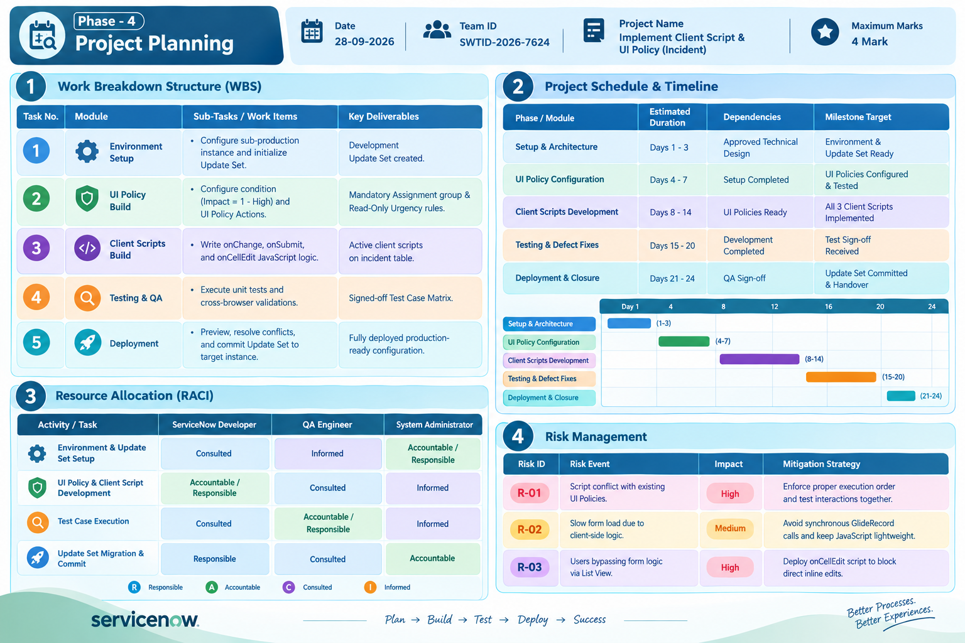
- Work Breakdown Structure (WBS) Table
Task Module | Sub-Tasks / Work Items | Key Deliverables
1. Environment Setup | Configure sub-production instance and initialize Update Set | Development Update Set created
2. UI Policy Build | Configure condition (Impact = 1 - High) and UI Policy Actions | Mandatory Assignment group & Read-Only Urgency rules
3. Client Scripts Build | Write onChange, onSubmit, and onCellEdit JavaScript logic | Active client scripts on incident table
4. Testing & QA | Execute unit tests and cross-browser validations. | Signed-off Test Case Matrix
5. Deployment | Preview, resolve conflicts, and commit Update Set to target instance. | Fully deployed production-ready configuration

- Project Schedule & Timeline Table
Phase / Module | Estimated Duration | Dependencies | Milestone Target
Setup & Architecture | Days 1 - 3 | Approved Technical Design | Environment & Update Set Ready
UI Policy Configuration | Days 4 - 7 | Setup Completed | UI Policies Configured & Tested
Client Scripts Development | Days 8 - 14 | UI Policies Ready | All 3 Client Scripts Implemented
Testing & Defect Fixes | Days 15 - 20 | Development Completed | Test Sign-off Received
Deployment & Closure | Days 21 - 24 | QA Sign-off | Update Set Committed & Handover

- Resource Allocation (RACI) Table
Activity / Task | ServiceNow Developer | QA Engineer | System Administrator
Environment & Update Set Setup | Consulted | Informed | Accountable / Responsible
UI Policy & Client Script Development | Accountable / Responsible | Consulted | Informed
Test Case Execution | Consulted | Accountable / Responsible | Informed
Update Set Migration & Commit | Responsible | Consulted | Accountable

- Risk Management Table
Risk ID | Risk Event | Impact | Mitigation Strategy
R-01 | Script conflict with existing UI Policies | High | Enforce proper execution order and test interactions together
R-02 | Slow form load due to client-side logic. | Medium | Avoid synchronous GlideRecord calls and keep JavaScript lightweight
R-03 | Users bypassing form logic via List View | High | Deploy onCellEdit script to block direct inline edits

